

**University of engineering & technology Peshawar**

**Circuit & system-ll lab**

**Lab report no#03**

**Spring 2020**

**Submitted by: Ashfaq Ahmad**

**Section: B**

**Reg No: 19PWCSE1795**

**Semester: 3rd**

**“On my honor, as a student of University of Engineering and Technology Peshawar, I have neither given nor received unauthorized assistance on this academic work”**

Student signature: ____________________

**Submitted to:**

**Eng: Faiz ullah**

**Department Of Computer System Engineering**

**Inductive Reactance (RL-circuit)**

**Objective**

* Inductive reactance will be examined in this exercise. In particular, its relationship to inductance and frequency will be investigated, including a plot of inductive reactance versus frequency.

**Theory Overview**

* The current – voltage characteristic of an inductor is unlike that of typical resistors. While resistors show a constant resistance value over a wide range of frequencies, the equivalent ohmic value for an inductor, known as inductive reactance, is directly proportional to frequency. The inductive reactance may be computed via the formula:

**XL= 2πfL**

* The magnitude of inductive reactance may be determined experimentally by feeding an inductor a known current, measuring the resulting voltage, and dividing the two, following Ohm’s Law. This process may be repeated across a range of frequencies in order to obtain a plot of inductive reactance versus frequency.
* An AC current source may be approximated by placing a large resistance in series with an AC voltage, the resistance being considerably larger than the maximum reactance expected.
* In RL-circuit voltage lead by 90 degree.

**Equipment**

1. AC Function Generator
2. Oscilloscope DMM

**Components**

1. 1mH actual:__________________
2. 10 mH actual:__________________
3. 10 kΩ actual:__________________
4. 10V:

**Figure 1** 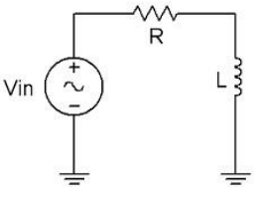

**Procedure**

1. **Current Source**

Using Figure 1 with Vin=10 Vp-p and R=10 kΩ, and assuming that the reactance of the inductor is much smaller than 10k and can be ignored, determine the circulating current using measured component values and record in Table 1.

1. **Measuring Reactance**

Build the circuit of Figure 1 using R=10 kΩ, and L=10 mH. Place one probe across the generator and another across the inductor. Set the generator to a 1000 Hz sine wave and 10Vp-p. Make sure that the Bandwidth Limit of the oscilloscope is engaged for both channels. This will reduce the signal noise and make for more accurate readings.

1. Calculate the theoretical value of XL using the measured inductor value and record in Table2.
2. Record the peak-to-peak inductor voltage and record in Table 2.
3. Using the source current from Table 1 and the measured inductor voltage, determine the experimental reactance and record it in Table 2. Also compute and record the deviation.
4. Repeat steps three through five for the remaining frequencies of Table 2.
5. Replace the 10 mH inductor with the 1mH unit and repeat steps two to six, recording results in Table 3.
6. Using the data of Tables 2 and 3, create plots of inductive reactance versus frequency.

**Formulae:**

* Current= function generator output/resistance

//(current will be constant in each experiment)

* Voltage across inductor = no of division in graph *reading of voltage per division in channel B.
* %deviation= (**XL theoretical – XL exp / XL theoretical)*100**
* Generator Voltage = 10k v

//(constant in each experiment)

* Theoretical value **= VL /I(p-p)**
* **Experimental value=**

**XL= 2πfL**

**Real experiment picture:**

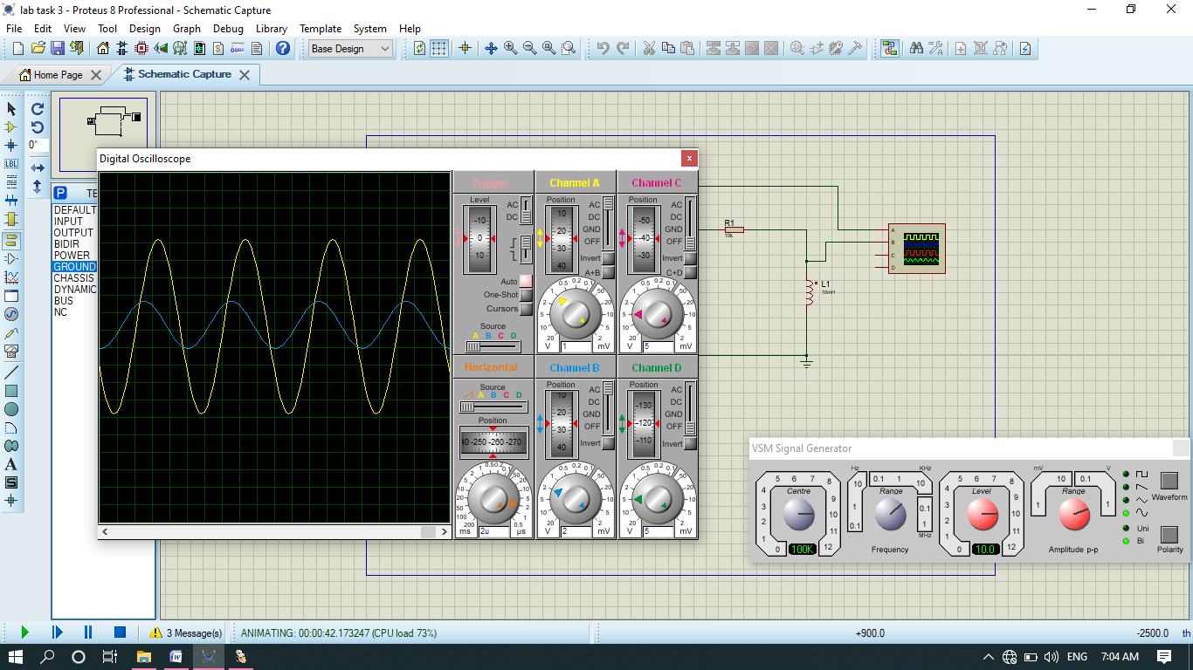

Table 1:

|  |  |
| --- | --- |
| **Current value I(p-p)** | **0.001A** |

Table 2:

For inductance=1.0mH

|  |  |  |  |  |
| --- | --- | --- | --- | --- |
| FREQUENCY | XL THEORETICAL | VL (P-P)EXP | XL EXP | %DEV |
| 1K | **6.4** | **0.0064** | **6.3** | **1.5%** |
| 2K | **12.8** | **0.0128** | **12.5** | **2.34%** |
| 3K | **18.6** | **0.0186** | **18.8** | **-1.07%** |
| 4K | **25.6** | **0.0256** | **25.12** | **-2.34%** |
| 5K | **32** | **0.032** | **31.4** | **1.87%** |
| 6K | **38** | **0.038** | **37.68** | **0.84%** |
| 7K | **45** | **0.045** | **43.96** | **0.88%** |
| 8K | **51** | **0.051** | **50.24** | **1.45%** |
| 9K | **57** | **0.057** | **56.52** | **0.84%** |
| 10K | **65** | **0.065** | **62.8** | **0.33%** |

Table 3:

For inductance=2mH

|  |  |  |  |  |
| --- | --- | --- | --- | --- |
| frequency | XL theoretical | VL (p-p)exp | XL exp | %dev |
| 10k | **640** | **0.64** | **628** | **1.87%** |
| 11k | **700** | **0.7** | **690.8** | **1.54%** |
| 30k | **1860** | **1.90** | **1884** | **-1.29%** |
| 40k | **2500** | **2.5** | **2512** | **-0.48%** |
| 50k | **3000** | **3** | **3140** | **-4.6%** |
| 60k | **3500** | **3.5** | **3768** | **-7.6%** |
| 70k | **4050** | **4.05** | **4396** | **-8.57%** |
| 80k | **4500** | **4.5** | **5001** | **-11.13%** |
| 90k | **5000** | **5** | **5652** | **-13.04%** |
| 100k | **5400** | **5.4** | **6284** | **-16.37%** |

Note:

Voltage across the inductor increase as frequency increase. It is because frequency is directly propositional to inductive reactance, while inductive reactance is a resister of inductor so if frequencies increase then resistance increase and according to ohm law voltage across inductor also increase.

Questions

1. What is the relationship between inductive reactance and frequency?

**Answer:** there is direct relation between inductive reactance and frequency.

1. What is the relationship between inductive reactance and inductance?

**Answer:** there is direct relation between inductive reactance and inductance.

1. If the 10mH trial had been repeated with frequencies 10 times higher than those in Table 2, what effect would that have on the experiment?

**Answer:** if we increase frequency more and more than the magnitude of error increase in negative direction and no of division in plot of channel B increase due to which voltage across inductor also increase which is true according to the mathematical expression of inductive reactance. As we know that there is inverse relation between time period and frequency so time period and wavelength of the graph decrease as frequency increase.

**Note:** in case of decreasing frequency the process will be inverse I,e those quantities which increase will decrease in this case, while those quantities which decrease will increase in this case.

1. Do the coil resistances have any effect on the plots?

**Answer:** The effect of an inductor in a circuit is to oppose changes in current through it by developing a voltage across it proportional to the rate of change of the current. An ideal inductor would offer no resistance to a constant direct current; however only superconducting inductors have truly zero electrical resistance.

The resistance of inductor effect the current due to which it lag by the 90 degree compared to the voltage.

**THE END**